The University of Azad Jammu and Kashmir, Muzaffarabad
Name | Danial Ayub Mughal
Roll Number | 2024-SE-20
Class | 4rd Semester
Subject | Computer Networks (Lab task 04)
Course Code | CS-2203
Submitted To | Engr. Dr .Asma Javaid


Department of Software Engineering

Lab 04: Router CLI Configuration
Step 01: Accessing router CLI
In this step, the router CLI is accessed through Cisco Packet Tracer. This allows the user to interact with the router using commands.

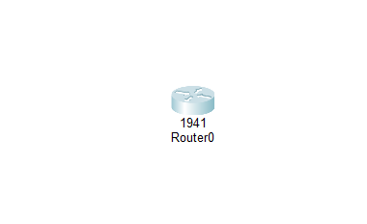

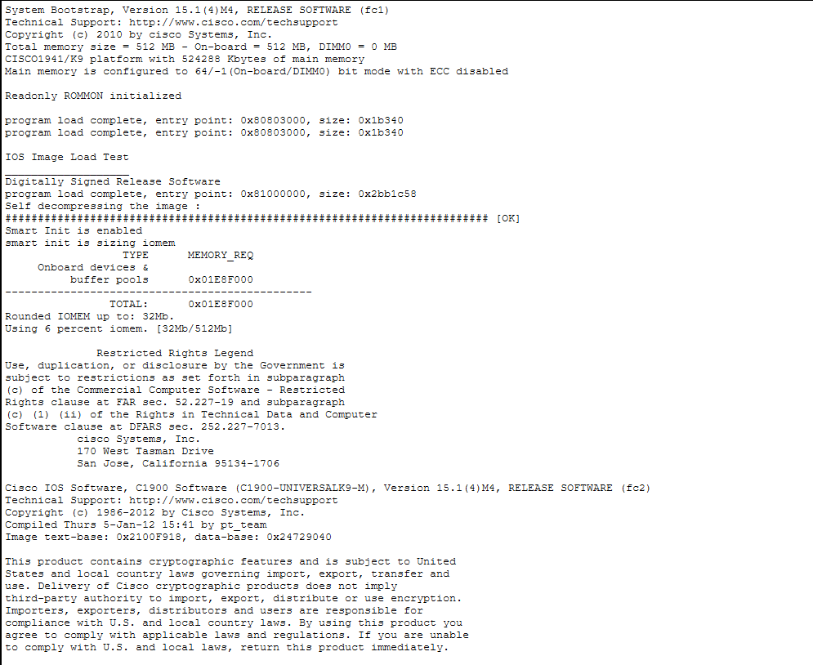
Step 2: Enter Privileged Mode
This command switches from User EXEC mode to Privileged EXEC mode, which provides full access to advanced commands and configurations.

Step 3: Enter Global Configuration Mode
This mode allows you to make changes to the router’s settings such as passwords, interfaces, and security configurations.
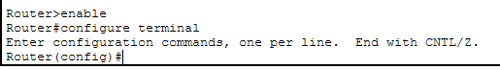

Step 4: Configure Enable Password
This sets a password required to enter privileged mode. However, it is stored in plain text, so it is less secure.

Step 5: Enable Password Encryption
This command encrypts all plain-text passwords in the configuration file to improve security.
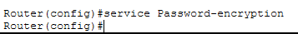

Step 6: Configure Enable Secret Password
This sets a more secure, encrypted password for privileged mode. It overrides the enable password and is recommended for security.

Step 7: Display Running Configuration
This command displays the current active configuration stored in RAM, including all recent changes.

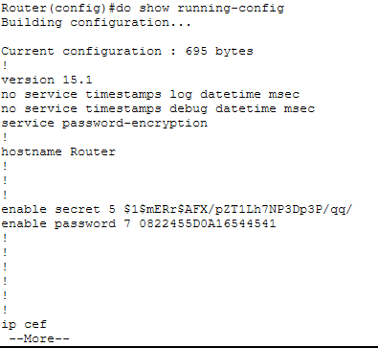

Step 8: Display Startup Configuration
This shows the saved configuration stored in NVRAM, which is used when the router restarts.
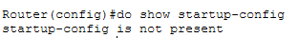

Step 9: Save Configuration
This command saves the current running configuration to startup configuration so that all changes are preserved after reboot.
